**ASSIGNMENT -1**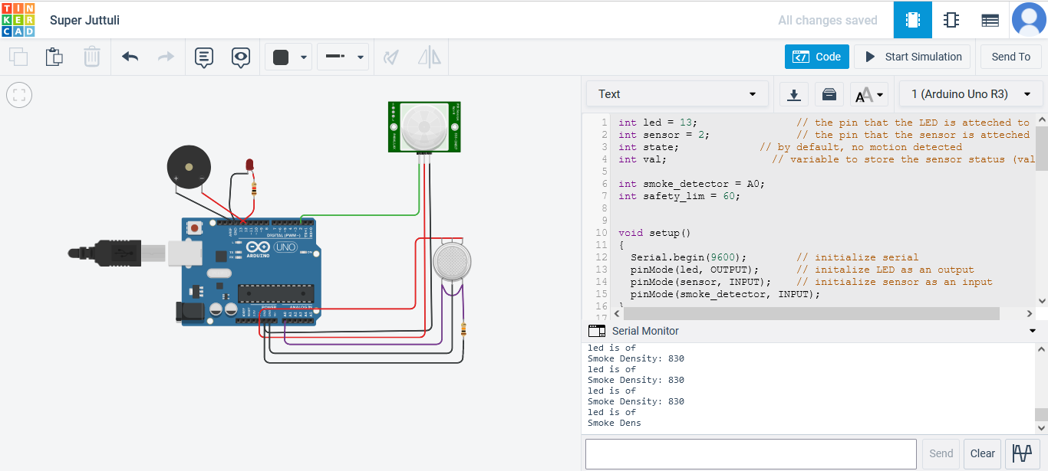

# SUBMITTED BY

DHARANI